For Worldwide Release: August 2014
Release Number: 13113

TERRATEC TBMS DOUBLE BREAKTHROUGH IN INDIA

TERRATEC is proud to announce the first two TBM breakthroughs in New Delhi, India. The breakthroughs are on the CC-07 and CC-24 Projects for Delhi Metro Phase-III. Sixteen additional breakthroughs by TERRATEC TBMs are scheduled to occur in the course of the next few months.
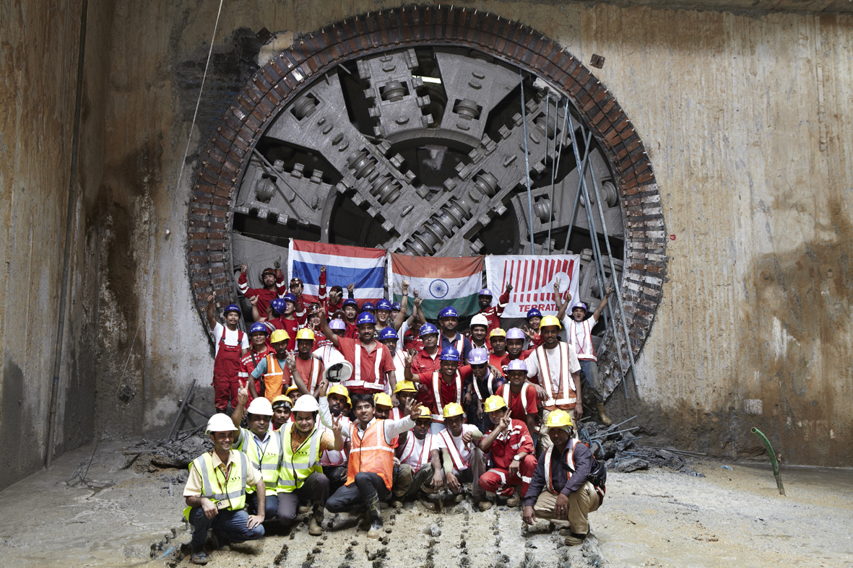

On July 31st, TERRATEC’s S23 Tunnel Boring Machine working in Contract CC-07 completed excavation on the down line from the Jama Masjid Station to the Lal Quila Station. The breakthrough ceremony was held in the presence of Contractor representatives from the joint venture between Metrostroy O.S. of Russia and ERA Infra Ltd. of India and Client DMRC.

On August 2nd, the S25 tunnel boring machine working in Contract CC-24 accomplished another breakthrough from the Hazarat Nizamuddin Station to the Ashram Station. The TBM has advanced a total of 1,665m inconspicuously and without causing any disturbance to the city's activities. The CC-24 Contractor is a joint venture between J.Kumar Infraprojects Ltd. of India and China Railway Third Group (CRTG) of China.

The next drive for TBM S25 is scheduled to complete the line between the Vinoba Puri Station and the Ashram Station.

The TERRATEC S23 and S25 EPBM TBMs are 6.61m in diameter and include state-of-the-art features such as the 900kw VFD electric driven CutterHead. They have a versatile design for either excavating soft ground with cutting tools or mixed ground and rock using up to 33 number 17’’ roller disc cutters. Both TBMs have active type articulation and 2-component grout backfilling systems.

The geology encountered to date at Project CC-07 included large quantities of fresh, very hard (up to 200MPA) and very abrasive quartzite. In addition to sections with a full face of rock, there were sections with very variable mixed ground conditions with numerous large diameter boulders. TERRATEC TBMs handled the challenging geological conditions and completed the drive succesfully.

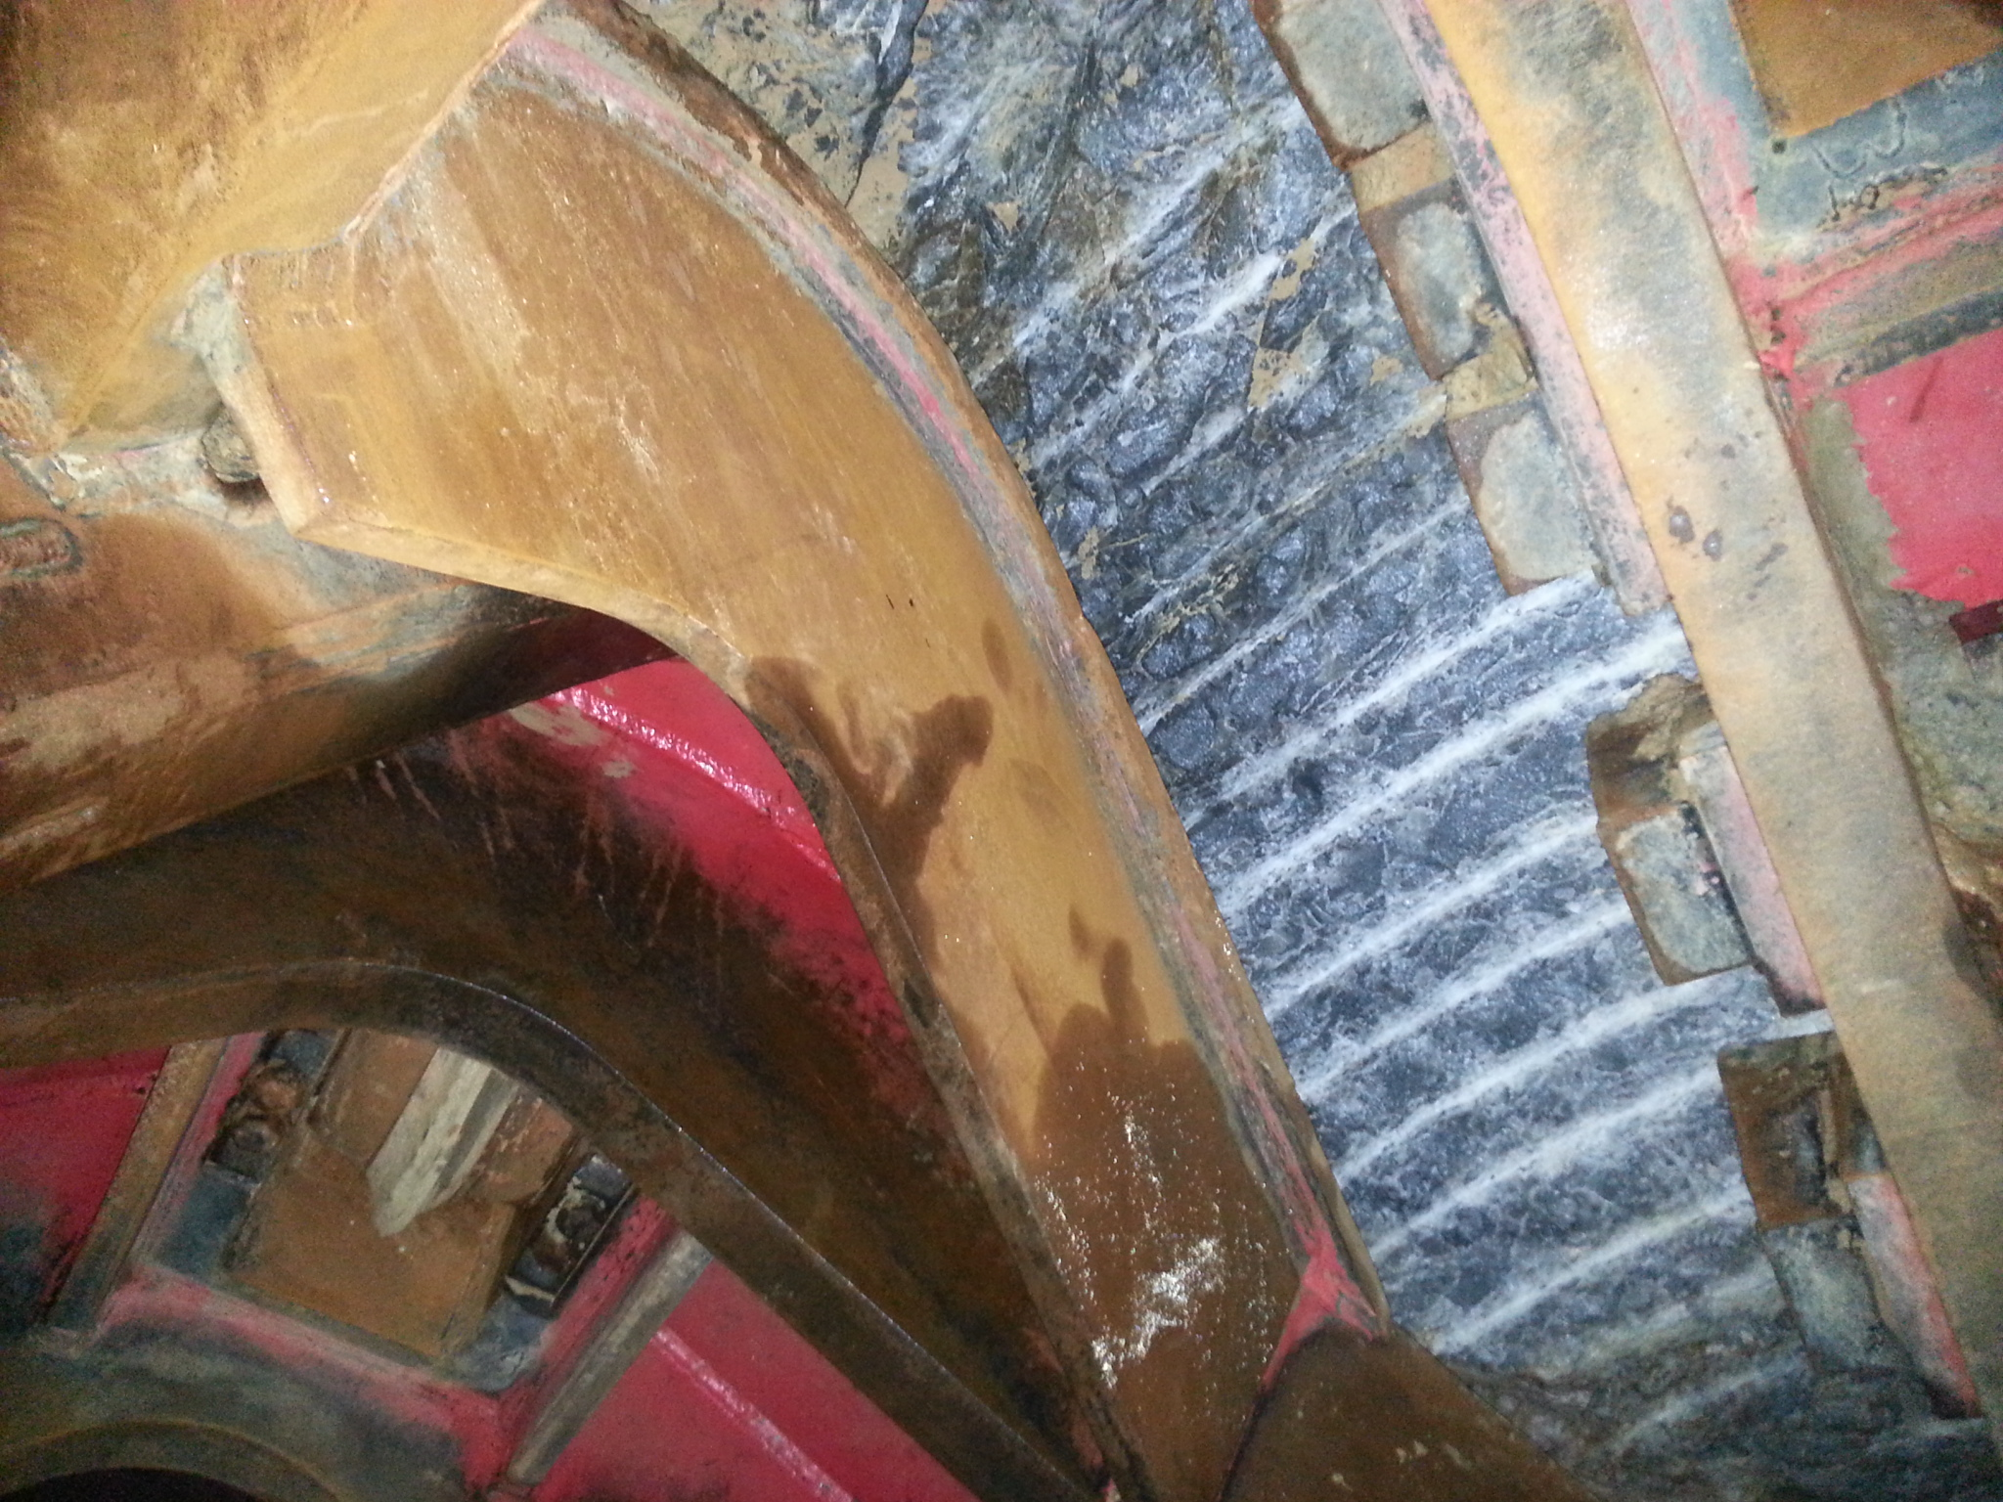 | 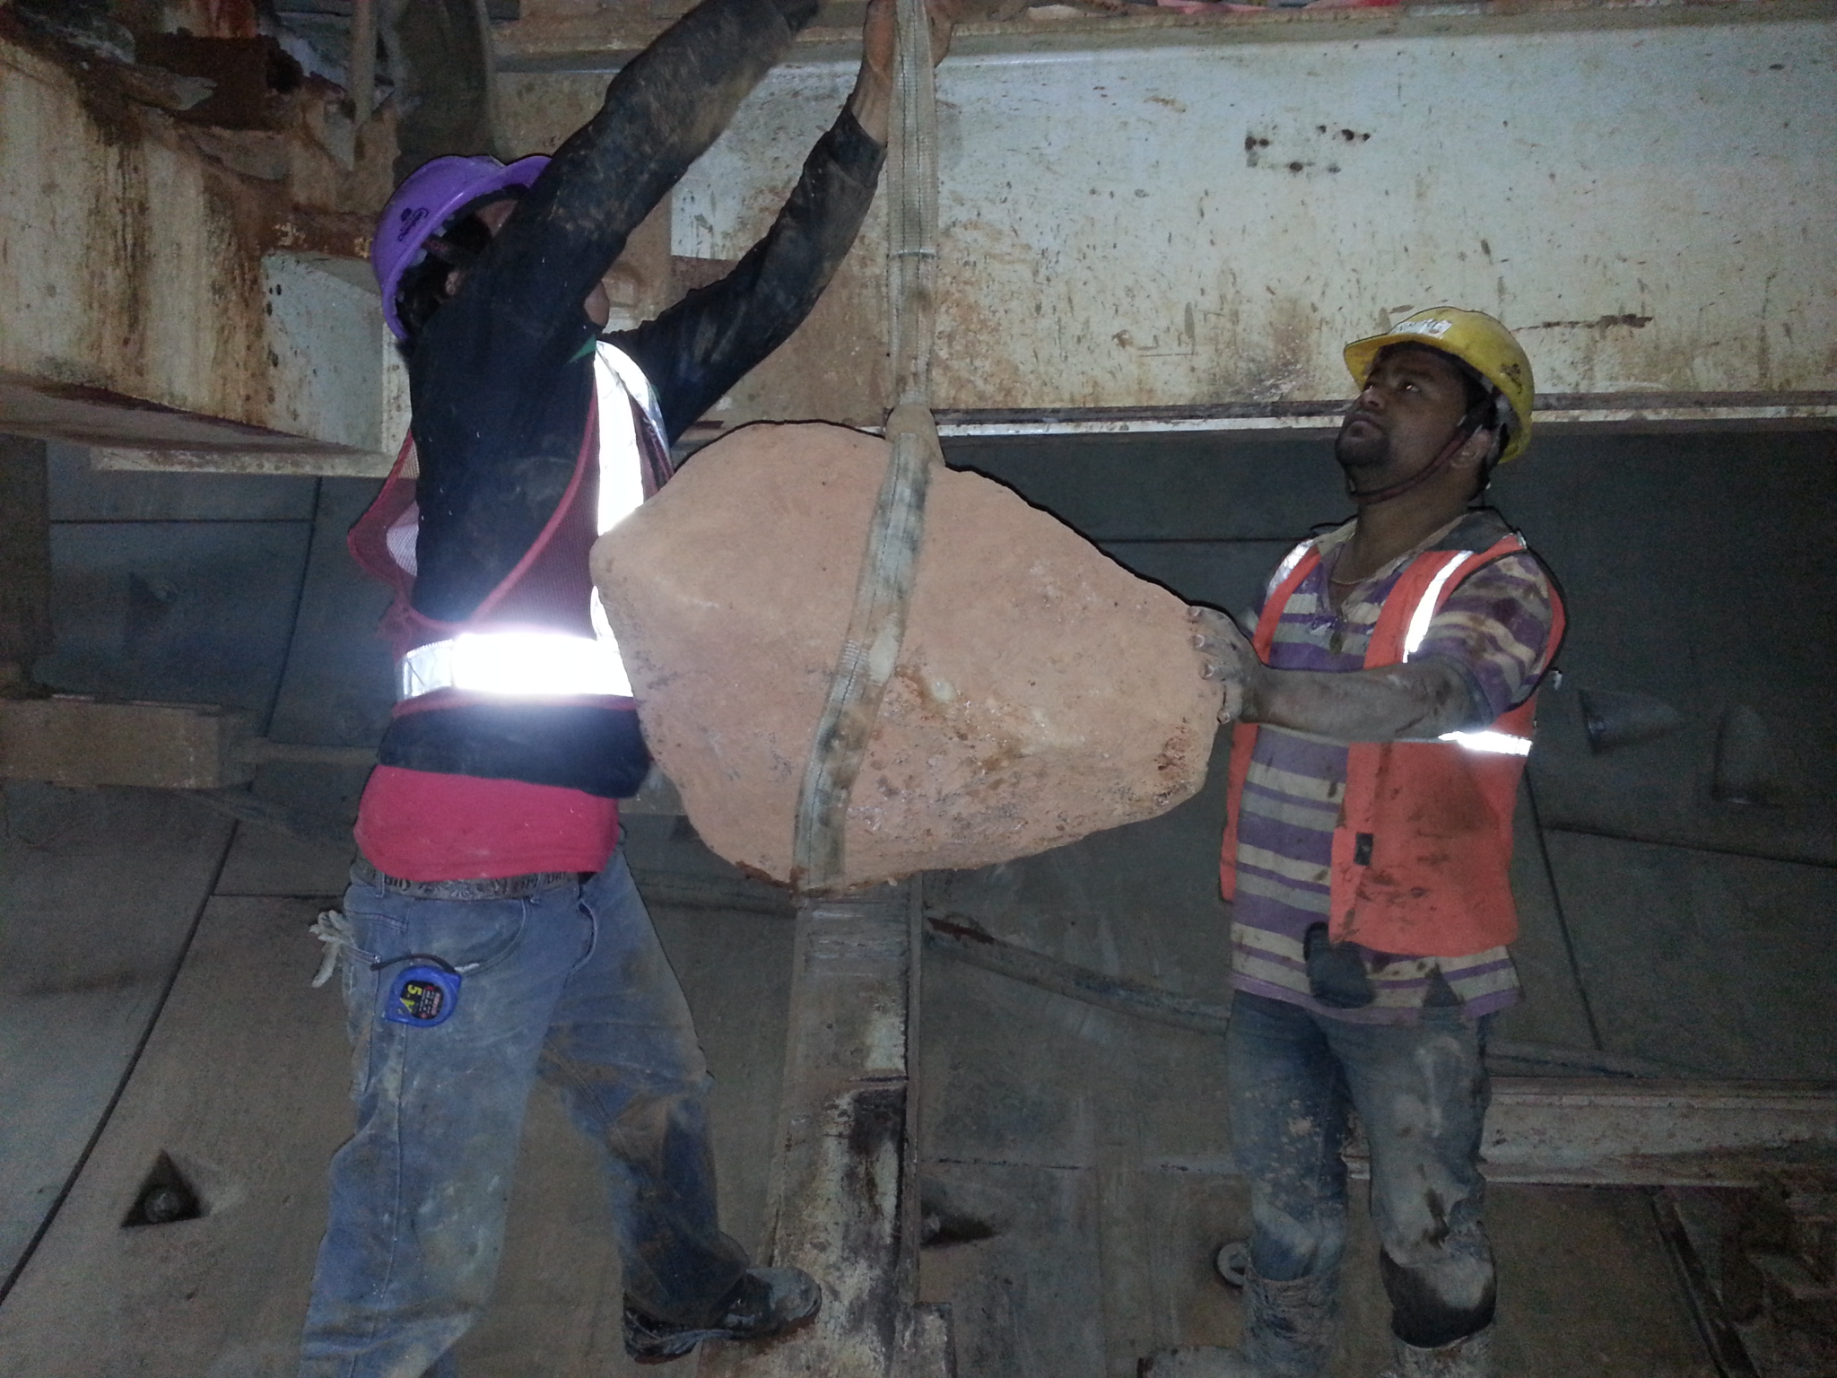
Project CC-07: Picture from inside of the TBM CutterHead  showing the very hard quartzite. | Project CC-07: Boulders of sizes up to 450mm were found  passing through the TBM Screw Conveyor.

TERRATEC has eight Tunnel Boring Machines currently excavating metro tunnels for Delhi Metro Phase III. Work will continue through 2014 with completion in 2015.

Press inquiries: info@terratec.co

